2018 GERMANY ALUMNI CHAPTER

SCHOLARSHIP PROGRAM INSTRUCTIONS

- Save the blank application to your desktop in this format:
  - 2018 GAC Scholarship Application First Name Last Name
- Complete the application and digitally sign it
- Follow these directions to digitally sign your application:
You will digitally sign the signature line in Part XVII – SIGNATURES

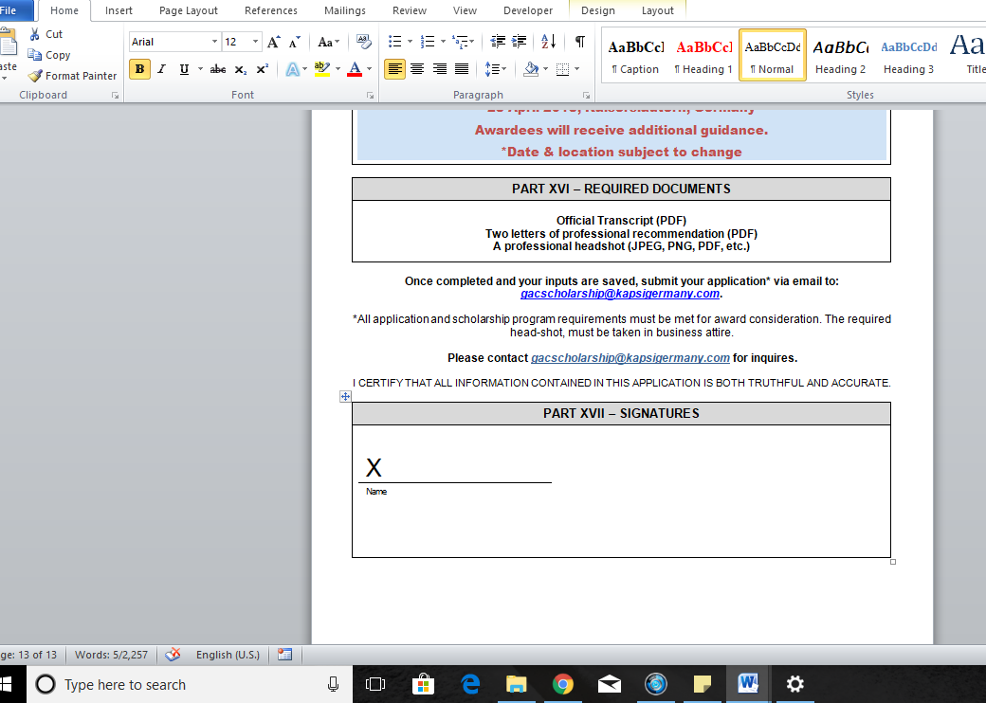

- Double Click the box, and the Microsoft Word dialogue box for a digital signature will appear, click “ok”.

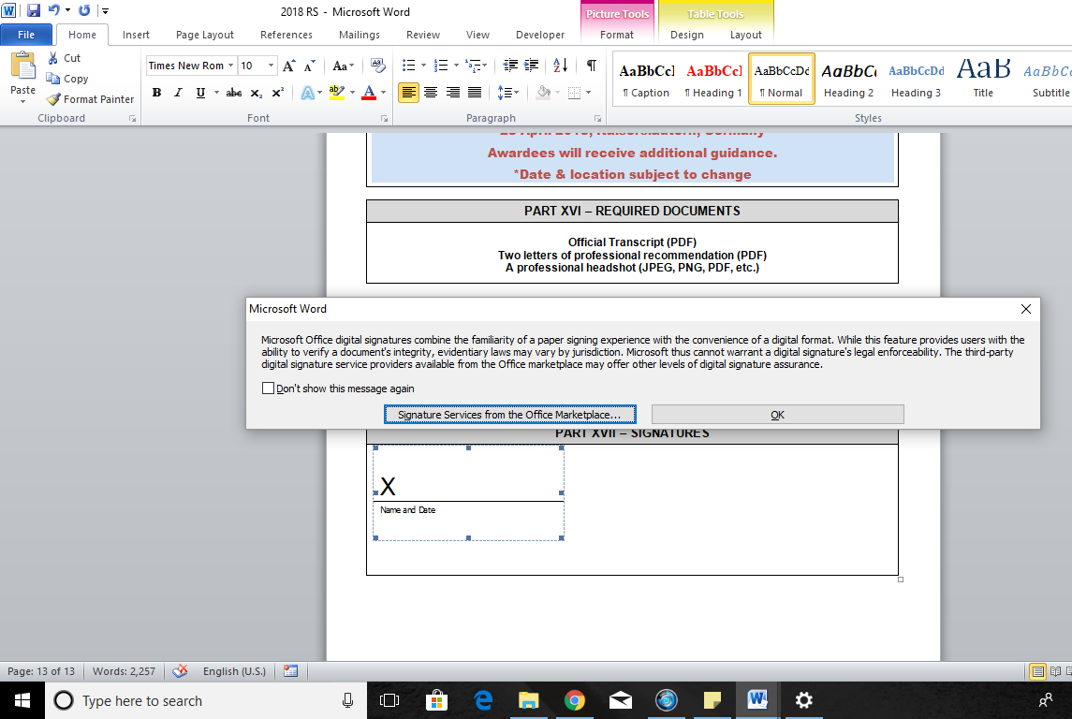

- Enter your name and the date

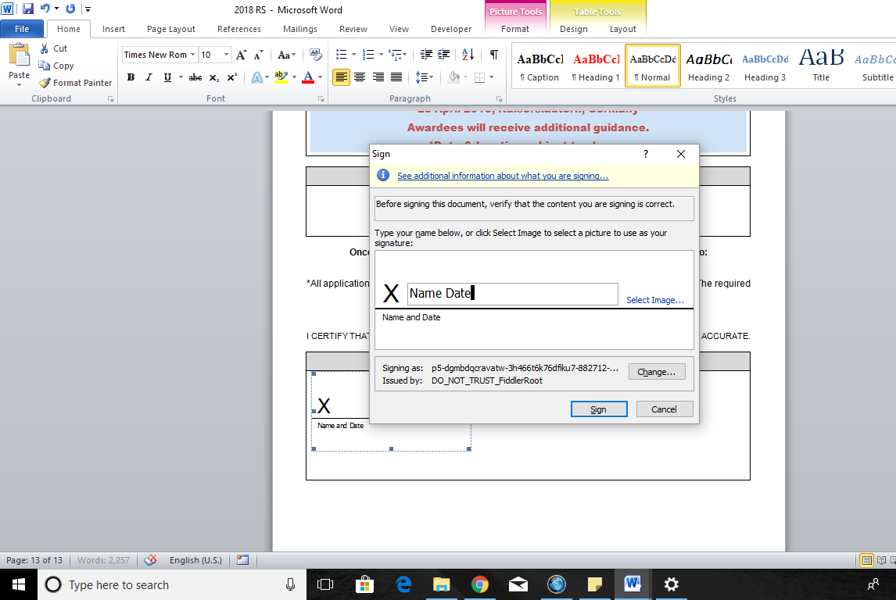

- A Microsoft Word certificate dialogue box will appear, click “yes”

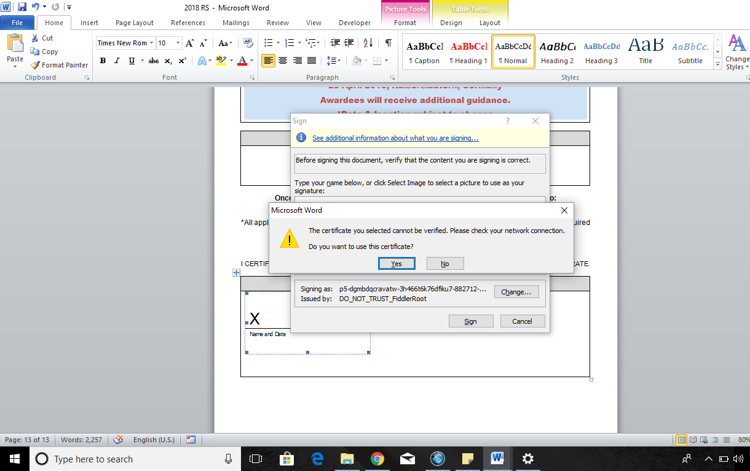

- Click “ok”

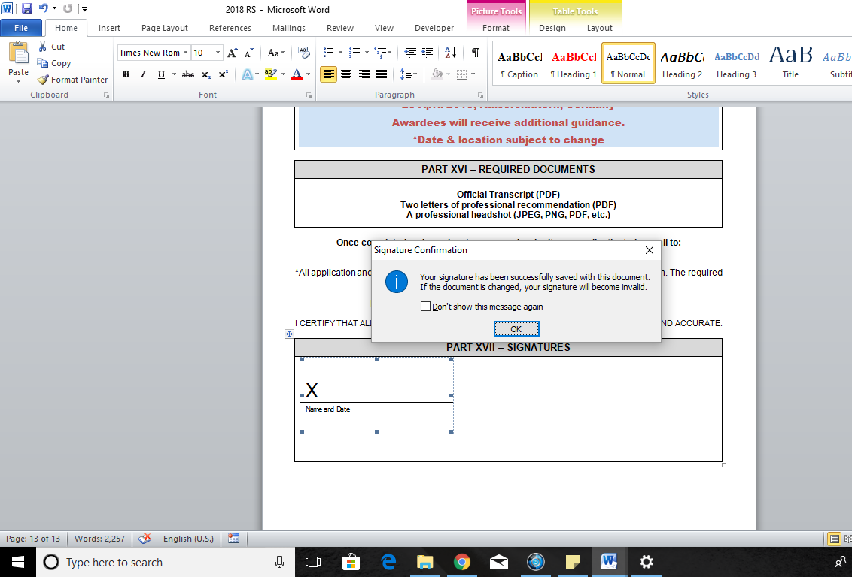

- Ignore the error messages, you have digitally signed your application.

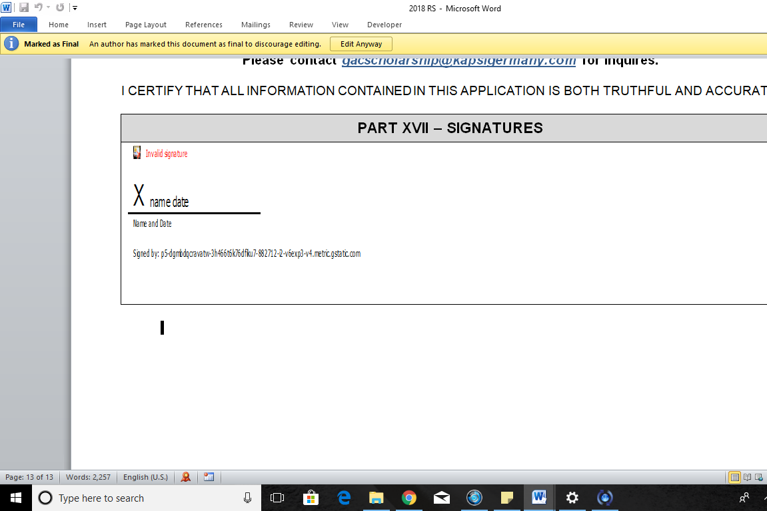
- Make sure your document is saved, submit your application and required documents to gacscholarship@kapsigermany.com

